Name: ____________________________ Surname: ____________________________ N^{ber}: ____ Grade/Class: _____
Assessment: _____________________________ | Date: ___________________________________________________
 | Teacher’s signature:  ___________________________ | Parent’s signature:  ___________________________

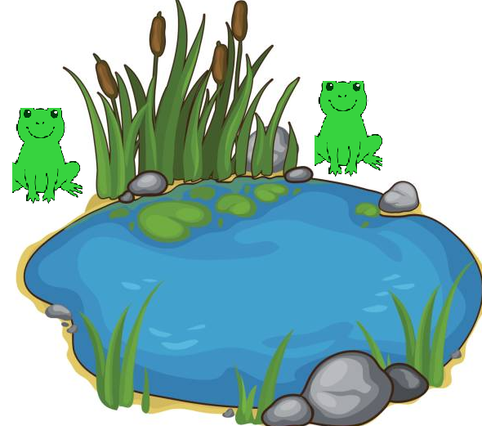
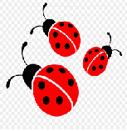
- Look and say.
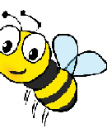
Is the frog green?
Is the ladybird blue?
Is the bee orange?
Are there two frogs?
Are there two bees?
Is there one ladybird?

Answer key:
Yes; No; No; Yes; No; No.

