Name: ____________________________ Surname: ____________________________ N^{ber}: ____ Grade/Class: _____
Assessment: _____________________________ | Date: ___________________________________________________
 | Teacher’s signature:  ___________________________ | Parent’s signature:  ___________________________

- Look at the picture and say.
😊 like/love
☹ don’t like/dislike

 | 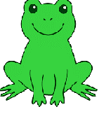 | 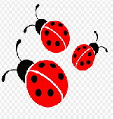 | 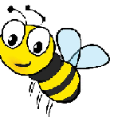 | 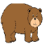
I | ☹ | 😊 | 😊 | ☹ | ☹ | 😊

Answer key:
I don’t like/dislike frogs.
I like/love ladybirds.
I like/love bees.
I don’t like/dislike bears.
I don’t like/dislike sharks.
I like/love dolphins.

