Name: ____________________________ Surname: ____________________________ N^{ber}: ____ Grade/Class: _____
Assessment: _____________________________  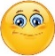  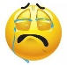 | Date: ___________________________________________________
 | Teacher’s signature:  ___________________________ | Parent’s signature:  ___________________________

- Complete.

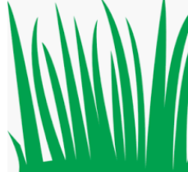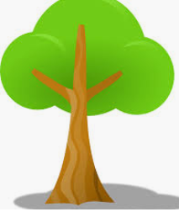

s ______________ g______________ t____________

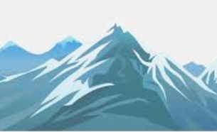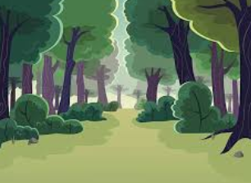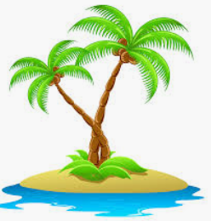

m ______________ f______________ i______________

2) Circle the correct answer.

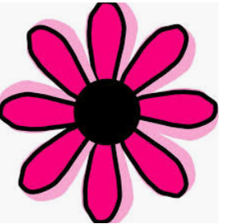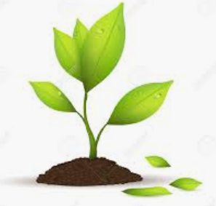
a. It's a flower / grass. b. It's a plant/ tree.
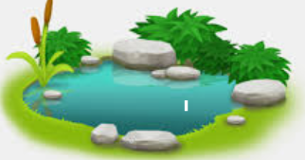
c. It's a sea/ river. d. It's a lake/ ocean.

Answer key
- sky; grass; tree; mountain; forest; island.
- Flower; plant; river; lake.

