Name: ____________________________ Surname: ____________________________ N^{ber}: ____ Grade/Class: _____
Assessment: _____________________________ | Date: ___________________________________________________
 | Teacher’s signature:  ___________________________ | Parent’s signature:  ___________________________

1) Label the pictures.

river | beach | lake | waterfall
ocean | forest | stars | sky

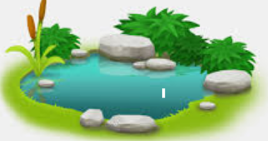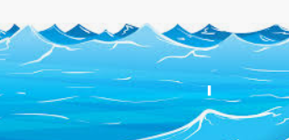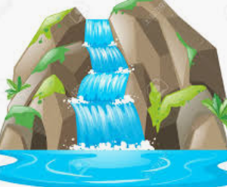
______________ ______________ ______________ ______________

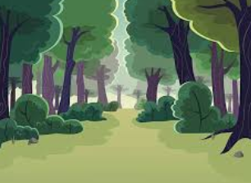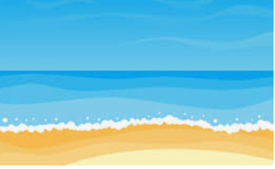

______________ ______________ ______________ ______________

2) Complete with the words from the box.

- The ______________ is blue .
sky forest beach
hills flowers mountain
- The ______________ is green.
- The ______________ are red.
- The ______________ is sandy.
- The ______________ is rocky.
- The ______________ are green.

Answer key
- Lake; ocean; waterfall; river; sky; forest; stars; beach.
- Sky; forest; flowers; beach; mountain; hills.

