Name: ____________________________ Surname: ____________________________ N^{ber}: ____ Grade/Class: _____
Assessment: _____________________________ | Date: ___________________________________________________
 | Teacher’s signature:  ___________________________ | Parent’s signature:  ___________________________

1) Fill in the gaps.
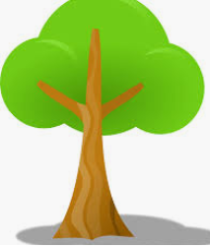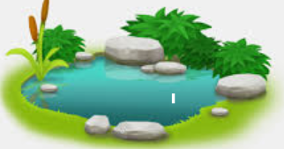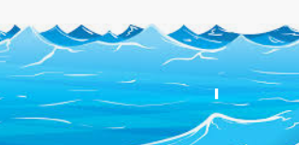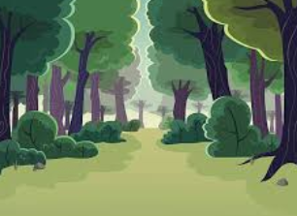

t__ __ e l__ __e o__ __ __ n __o__e s t

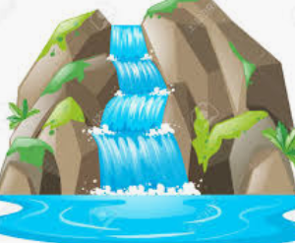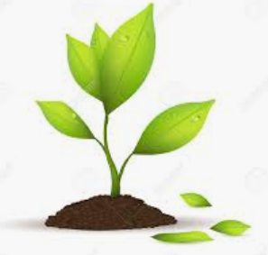

__a __ e__ f__ __ l be__ __h g__ __ ss p__ a__ t

2) Find the words from exercise 1.

w | a | t | e | r | f | a | l | l | j
a | v | r | e | v | o | c | e | a | n
f | x | e | h | f | r | k | k | k | s
a | a | e | s | g | e | g | o | e | d
p | l | a | n | t | s | x | d | d | e
g | r | a | s | s | t | w | a | o | w
b | e | a | c | h | t | f | u | o | r

Answer key
- Tree; lake; ocean; forest; waterfall; beach; grass, plant.

w | a | t | e | r | f | a | l | l
 |  | r |  |  | o | c | e | a | n
 |  | e |  |  | r |  |  | k
 |  | e |  |  | e |  |  | e
p | l | a | n | t | s
g | r | a | s | s | t
b | e | a | c | h

