Name: ____________________________ Surname: ____________________________ N^{ber}: ____ Grade/Class: _____
Assessment: _____________________________ | Date: ___________________________________________________
 | Teacher’s signature:  ___________________________ | Parent’s signature:  ___________________________

- Match.

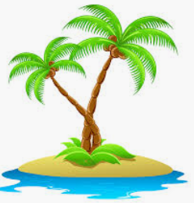 | 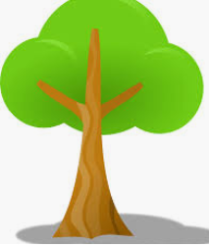 | 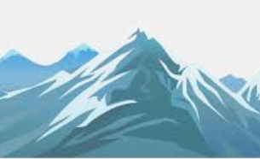 |  | 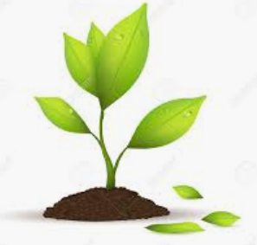
mountain | flower | tree | island | beach | plant

2) Draw.

Draw a beach | Draw two plants | Draw five stars | Draw six flowers
Draw four trees | Draw the moon | Draw tree sunflowers | Draw one lake

Answer key
- Island; tree; mountain; flower; plant; beach
- Drawing

