Name: ____________________________ Surname: ____________________________ N^{ber}: ____ Grade/Class: _____
Assessment: _____________________________ | Date: ___________________________________________________
 | Teacher’s signature:  ___________________________ | Parent’s signature:  ___________________________

1) Match.

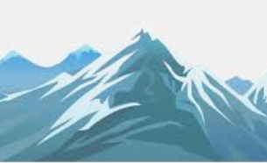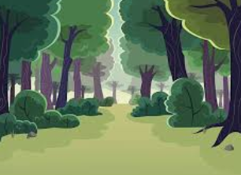

- I don't like fire. | 1)...the blue sky.
- I like watching... | 2) It is dangerous.
- I like walking... | 3)....but I like walking up a hill.
- I don't like climbing up a mountain... | 4)...in the green forest.

2) Complete the words.

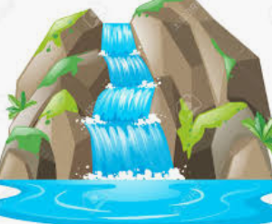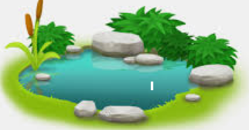

w______________________ p_____________________ l____________________ h____________________

o____________________ r____________________ s____________________ b____________________

Answer key

- A-2; b-1; c-4; d-3.
- Waterfall, plant; lake; hill; ocean; river; sky; beach.

