Name: ____________________________ Surname: ____________________________ N^{ber}: ____ Grade/Class: _____
Assessment: _____________________________ | Date: ___________________________________________________
 | Teacher’s signature:  ___________________________ | Parent’s signature:  ___________________________

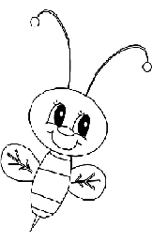
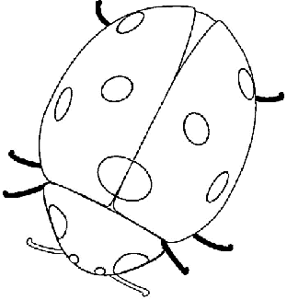
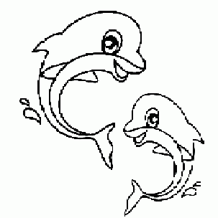
- Colour and write.
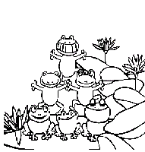
This is a _______ This is a _______
This is a ________ That is a _________
2) Look and write.
a) The frog is ______
b) The ladybird is ____
c) The dolphin is _____
d) The bee is _____

Answer key.
- Ladybird; dolphin; bee; frog.
- Green; red; blue; yellow.

