Name: ____________________________ Surname: ____________________________ N^{ber}: ____ Grade/Class: _____
Assessment: _____________________________  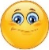 | Date: ___________________________________________________
 | Teacher’s signature:  ___________________________ | Parent’s signature:  ___________________________

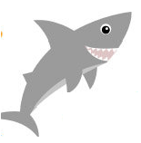
- Write.
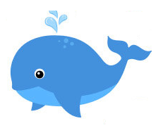
The _____ is _____. It isn’t blue.
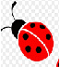
The _____ is _____. It isn’t yellow.

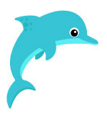
The _____ is _____. It isn’t blue.
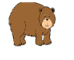
The _____ is ____. It isn’t red.
The ______ is _____. It isn’t red.

Answer key:
The shark is grey.
The whale is blue.
The ladybird is red.
The dolphin is blue.
The bear is brown.

