Name: ____________________________ Surname: ____________________________ N^{ber}: ____ Grade/Class: _____
Assessment: _____________________________ | Date: ___________________________________________________
 | Teacher’s signature:  ___________________________ | Parent’s signature:  ___________________________

- Write.
like
love
don’t like
dislike

 | 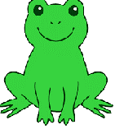 | 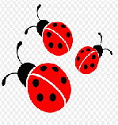 | 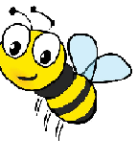 | 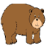
I

1.______________ frogs.
2.______________ladybirds.
3.______________ bees.
4.______________ bears.
5.______________ sharks.
6.______________ dolphins.

Answer key:
I don’t like frogs.
I love ladybirds.
I like bees.
I don’t like bears.
I dislike sharks.
I love dolphins.

