Name: ____________________________ Surname: ____________________________N^{ber}: ____ Grade/Class: _____
Assessment: _____________________________  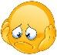 | Date: ___________________________________________________
 | Teacher’s signature:  ___________________________ | Parent’s signature:  ___________________________

- Listen and Link.

- Listen and tick.
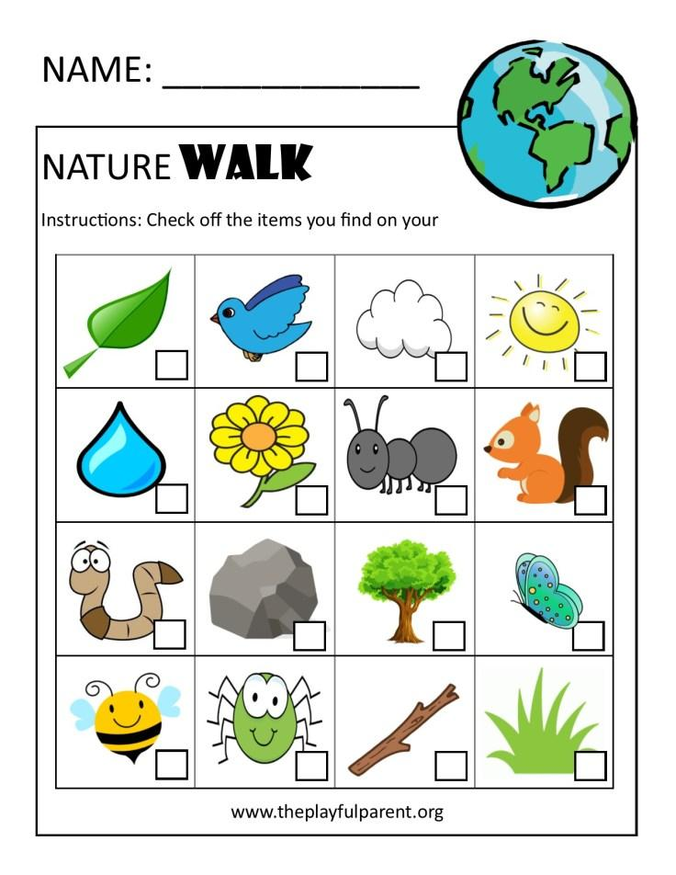

TRANSCRIPT

EXERCISE 1

Teacher:
- Cotton thread comes from cotton plants.
- Rubber tires come from rubber trees.
- Plastic cups are made in factories.
- Wool comes from sheep.

EXERCISE 1

Teacher: Jenny goes for a nature walk. Let’s see what she sees while walking.

- A Yellow flower
- A blue bird
- Snake
- Cloud
- Leaves
- Bee
- Grass

