Name: ____________________________ Surname: ____________________________N^{ber}: ____ Grade/Class: _____
Assessment: _____________________________ | Date: ___________________________________________________
 | Teacher’s signature:  ___________________________ | Parent’s signature:  ___________________________

- Listen and tick.

1 | 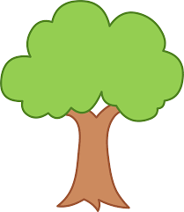 | 6 | 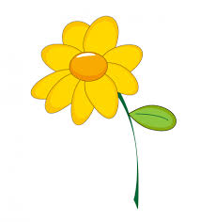
2 | 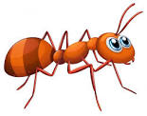 | 7 | 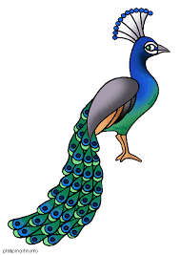
3 |  | 8 | 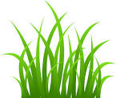
4 | 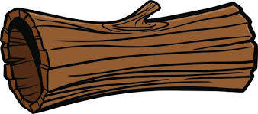 | 9 | 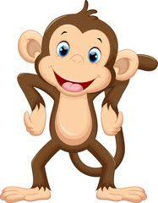
5 | 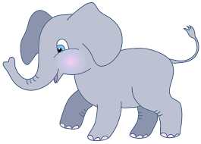 | 10 | 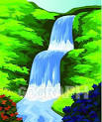

TRANSCRIPT

EXERCISE 1

Listen to the instructions and tick ‘yes’ or ‘no’ accordingly.

- It is a Tree.
- It is an Ant.
- It is a Moon.
- It is a Log.
- It is a Mouse.
- It is a Leaf.
- It is a Parrot.
- It is Grass.
- It is a Gorilla.
- It is a Lake.

