Name: ____________________________ Surname: ____________________________N^{ber}: ____ Grade/Class: _____
Assessment: _____________________________ | Date: ___________________________________________________
 | Teacher’s signature:  ___________________________ | Parent’s signature:  ___________________________

- Listen and match.
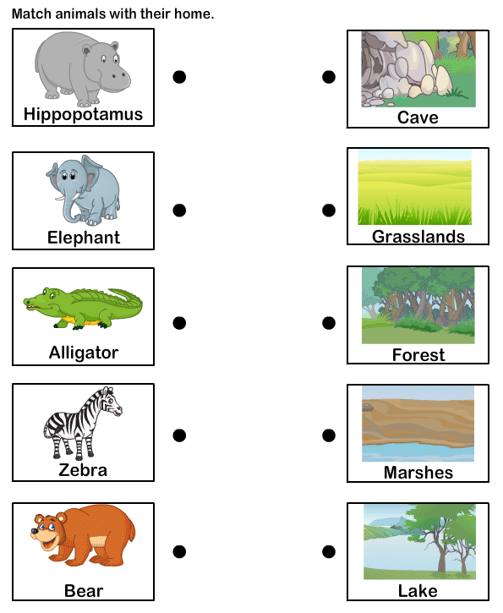

TRANSCRIPT

EXERCISE 1

Teacher: Let’s find the homes of some animals.

- Hippopotamus lives in marshes.
- Elephants live in a forest.
- Alligators live in a lake.
- Zebras live in grasslands.
- Bears live in a cave.

