Name: ____________________________ Surname: ____________________________N^{ber}: ____ Grade/Class: _____
Assessment: _____________________________ | Date: ___________________________________________________
 | Teacher’s signature:  ___________________________ | Parent’s signature:  ___________________________

- Listen and find.

- Listen and link.

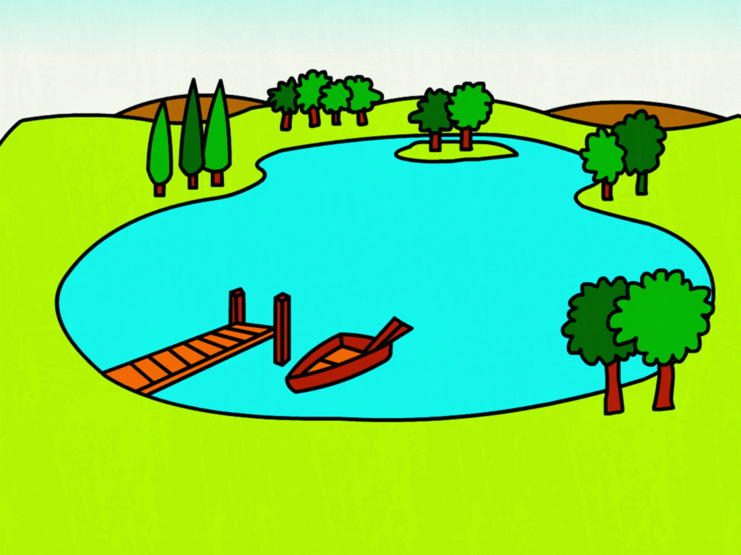
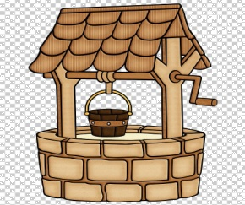
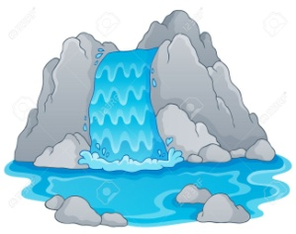

. . . .

. . . .
Jill
Fishes
Crocodile
Mary

TRANSCRIPT

EXERCISE 1

Listen to the words mentioned and find the words in the crossword puzzle:

- Planet
- Hills
- Tree
- Star
- Moon
- Sun
- Rainbow
- Leaf

EXERCISE 2

- Jill fetches water in a well.
- Fish live in a pond.
- Mary loves a waterfall.
- There is a crocodile in the lake.

