Name: ____________________________ Surname: ____________________________N^{ber}: ____ Grade/Class: _____
Assessment: _____________________________ | Date: ___________________________________________________
 | Teacher’s signature:  ___________________________ | Parent’s signature:  ___________________________

- Listen and number.

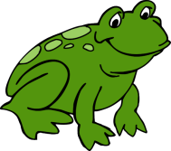
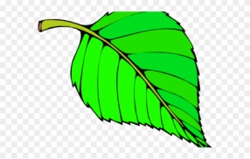
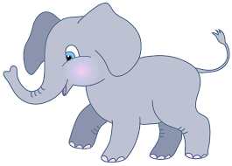
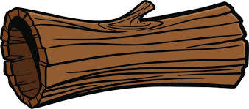

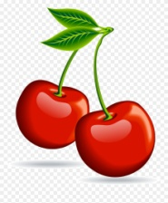
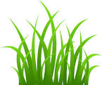
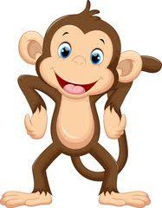

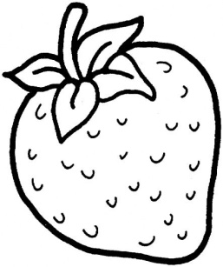
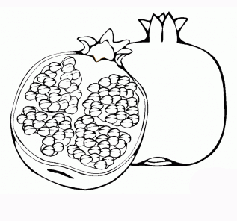
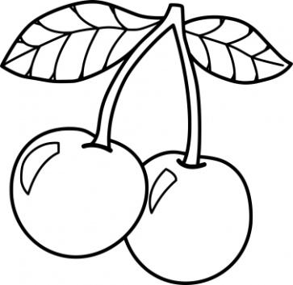
- Listen, link and colour.
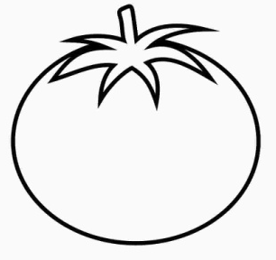

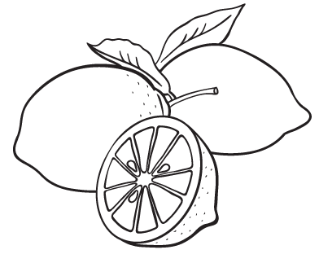

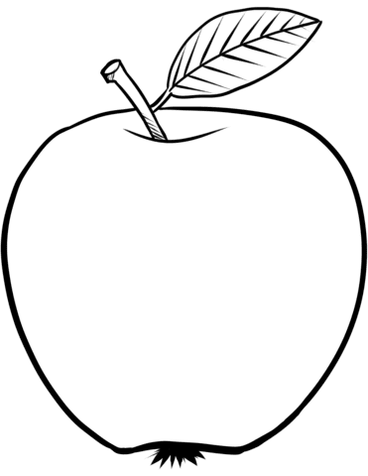

TRANSCRIPT

EXERCISE 1

- Frog
- Butterfly
- Leaf
- Cherries
- Log
- Grass
- Elephant
- Monkey

EXERCISE 2

What’s red in nature? Come, let’s link and color.

- Cherries
- Apple
- Strawberry
- Pomegranate
- Tomato

