Name: ____________________________ Surname: ____________________________N^{ber}: ____ Grade/Class: _____
Assessment: _____________________________ | Date: ___________________________________________________
 | Teacher’s signature:  ___________________________ | Parent’s signature:  ___________________________

- Listen and Match.
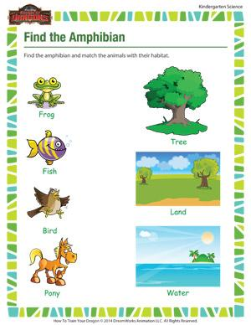

- Listen and tick.

TRANSCRIPT

EXERCISE 1

Teacher: Let’s find the habitat of some animals. Frog lives both on land and in water. Fish live in water. Birds live on a tree. Ponies live on land.

EXERCISE 1

Teacher: Children, fruits are sources of many essential nutrients.

- Grapes are green in color.
- Kiwi fruit is used as a food and as a medicine.
- Orange is rich in vitamin C.

