Name: ____________________________ Surname: ____________________________ N^{ber}: ____ Grade/Class: _____
Assessment: _____________________________ | Date: ___________________________________________________
 | Teacher’s signature:  ___________________________ | Parent’s signature:  ___________________________

Read the text.
Hi, I’m Molly. I love nature. I love dolphins and bears, but I don’t like sharks. I like ladybirds and bees, but I dislike frogs.
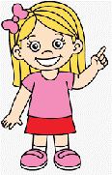

- Complete the chart. Put a tick or a cross.

 | 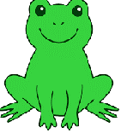 | 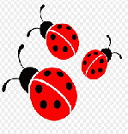 | 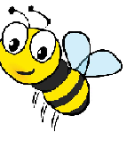 | 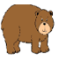
Molly

Answer key.
Molly | X | yes | yes | yes | X | yes

