Name: ____________________________ Surname: ____________________________ N^{ber}: ____ Grade/Class: _____
Assessment: _____________________________ | Date: ___________________________________________________
 | Teacher’s signature:  ___________________________ | Parent’s signature:  ___________________________

- Read and write numbers.
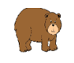
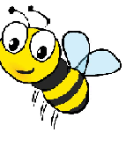
1. This is a dolphin. It’s big and blue.
b) ____________
2. This is a frog. It is green.

a) ____________

c) ____________
d) ____________
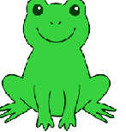
4. This is a bee. It is yellow and black.

3. This is a bear. It is big and brown.

2) Read and colour.
The bee is yellow and black. The flowers are pink, red and yellow.
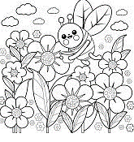

Answer key:
- A-4; b-3; c-2; d-1.
- colouring

