Name: ____________________________ Surname: ____________________________ N^{ber}: ____ Grade/Class: _____
Assessment: _____________________________ | Date: ___________________________________________________
 | Teacher’s signature:  ___________________________ | Parent’s signature:  ___________________________

- Read and complete the table. Put a tick.
There are dolphins and sharks in the sea.
There is a bear in the mountain.
There are pigeons and ladybirds in the forest.

 |  | 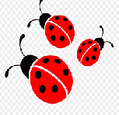 |  | 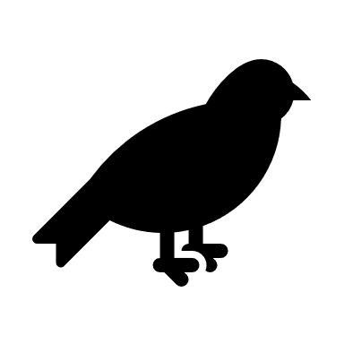 | 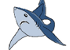
forest
sea
mountain

- Read and write Yes/No.
- Is there a bear in the sea?
- Are there pigeons in the forest?
- Are there dolphins in the sea?
- Are there sharks in the mountain?

Answer key: 1.
forest |  | X |  | X
sea |  |  | X |  | X
mountain | X

- no; yes; yes; no.

