Name: ____________________________ Surname: ____________________________ N^{ber}: ____ Grade/Class: _____
Assessment: _____________________________ | Date: ___________________________________________________
 | Teacher’s signature:  ___________________________ | Parent’s signature:  ___________________________

- Read, circle and colour.
This is a ladybird/frog. It is red/blue. It isn’t red/blue. The flowers are pink and yellow.
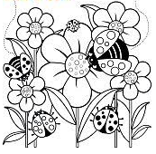

- Read and link.
This is a ladybird.
It is small and green.
1) A

This is a bear.
2) B

It is big and blue.

3) C

It is big and brown.
This is a frog.

4) D

It is small and red.
This is a dolphin.

Answer key:
- Colouring; ladybird; red; blue.
- 1-d; 2-c; 3-a; 4-b.

