Name: ____________________________ Surname: ____________________________ N^{ber}: ____ Grade/Class: _____
Assessment: _____________________________ | Date: ___________________________________________________
 | Teacher’s signature:  ___________________________ | Parent’s signature:  ___________________________

- Ask your partner.
Is there a dolphin in the forest?
Is there a shark in the sea?
Is there a frog in the mountain?
Is there a bear in the mountain?
Is there a ladybird in the forest?
Is there a bee in the sea?

 | 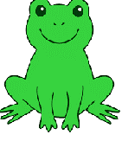 |  | 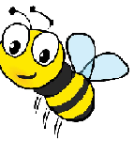 | 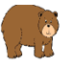
Your partner’s answers

- Answer your partner’s questions.

Answer key:
Your partner’s answers | No | Yes | No | Yes | Yes | No

