Name: ____________________________ Surname: ____________________________ N^{ber}: ____ Grade/Class: _____
Assessment: _____________________________ | Date: ___________________________________________________
 | Teacher’s signature:  ___________________________ | Parent’s signature:  ___________________________

- Teacher’s questions.
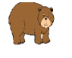
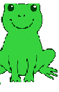
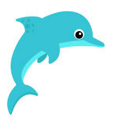
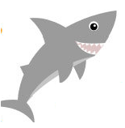

Do you like sharks?
Do you like whales?
Do you like bears?
Do you like dolphins?
Do you like frogs?
Do you like ladybirds?

Answer key:
Yes/No

