Name: ____________________________ Surname: ____________________________ N^{ber}: ____ Grade/Class: _____
Assessment: _____________________________ | Date: ___________________________________________________
 | Teacher’s signature:  ___________________________ | Parent’s signature:  ___________________________

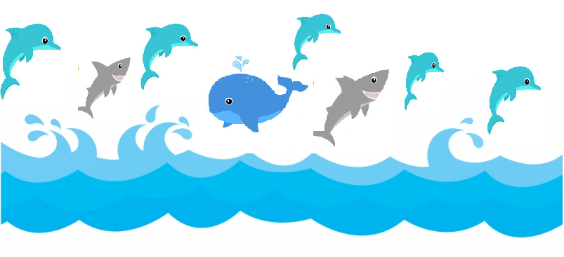
- Find the differences.
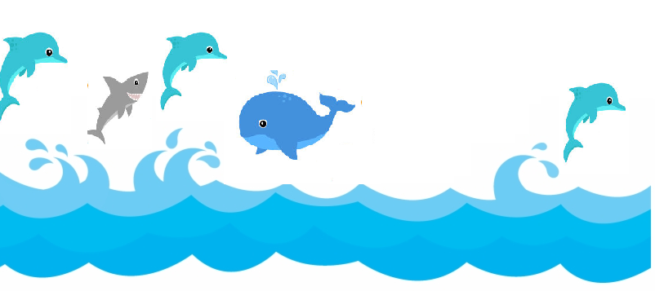

Answer key:
On picture B:
There is one shark.
There are three dolphins.

