Name: ____________________________ Surname: ____________________________ N^{ber}: ____ Grade/Class: _____
Assessment: _____________________________ | Date: ___________________________________________________
 | Teacher’s signature:  ___________________________ | Parent’s signature:  ___________________________

- Look and say.

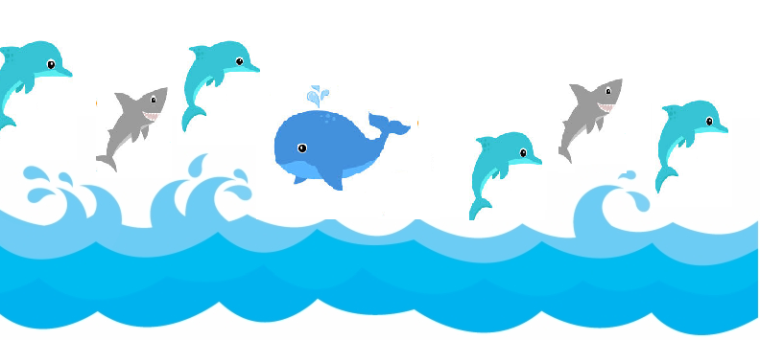

Are there two whales?
Is there one shark?
Are there four dolphins?
Is the whale blue?
Are the sharks blue?
Are the dolphins yellow?

Answer key:
No; No; Yes; Yes; No; No.

