Name: ____________________________ Surname: ____________________________ N^{ber}: ____ Grade/Class: _____
Assessment: _____________________________ | Date: ___________________________________________________
 | Teacher’s signature:  ___________________________ | Parent’s signature:  ___________________________

- Look at the picture and say.
like
love
don’t like
dislike

 | 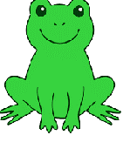 | 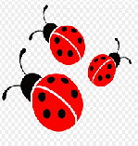 | 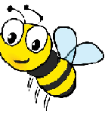 | 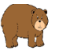
I

Answer key:
I don’t like frogs.
I love ladybirds.
I like bees.
I don’t like bears.
I dislike sharks.
I love dolphins.

