Name: ____________________________ Surname: ____________________________ N^{ber}: ____ Grade/Class: _____
Assessment: _____________________________  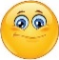  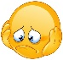  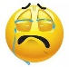 | Date: ___________________________________________________
 | Teacher’s signature:  ___________________________ | Parent’s signature:  ___________________________

- Unscramble.

n o u m t i a n ______________
o f r s t e ______________
e e b ______________
r e b a ______________
y s k ______________
e a s ______________
n p l a t ______________

- Label the pictures.

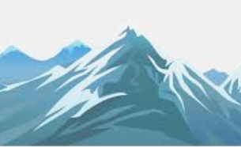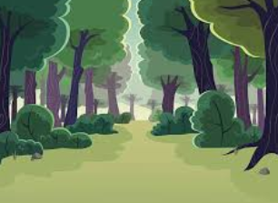

_________ _________ _______

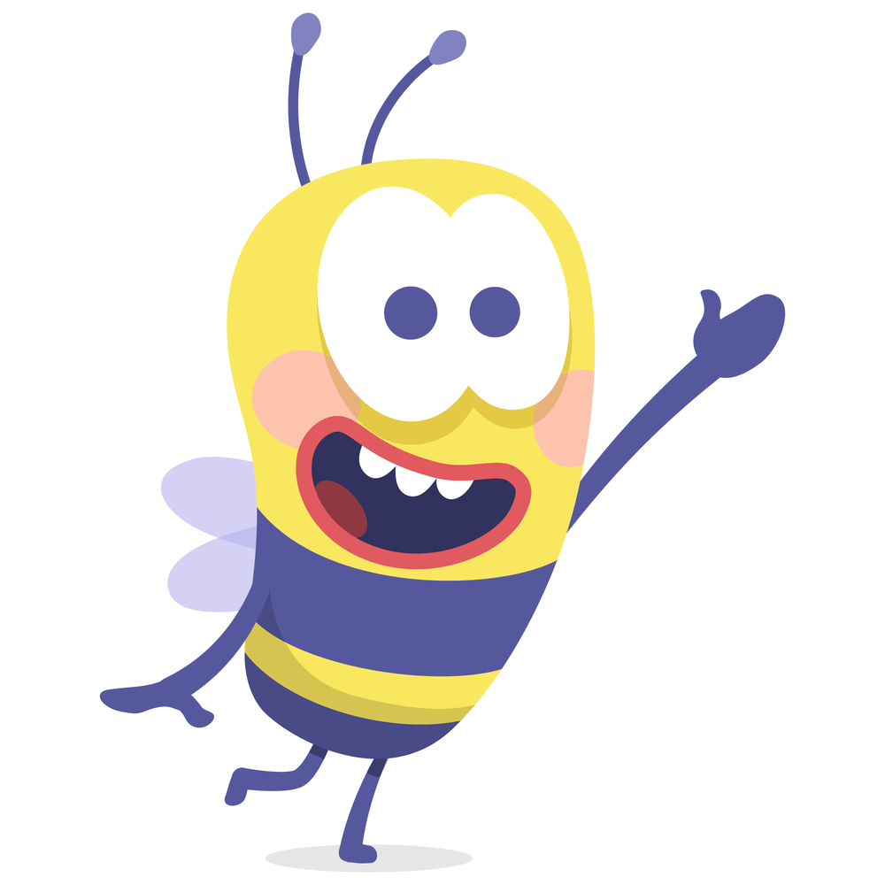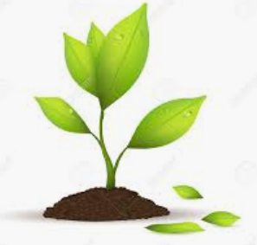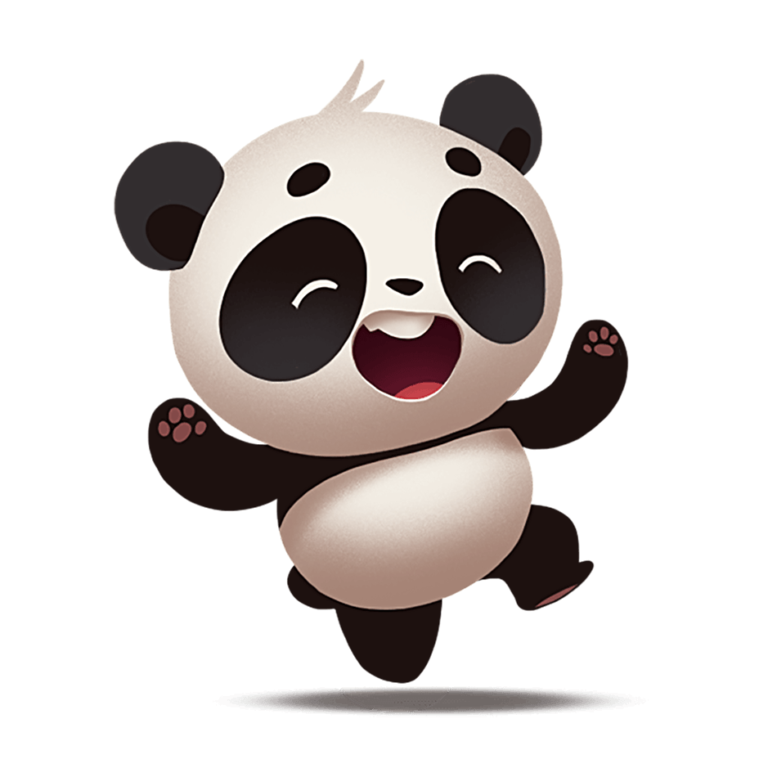
___________ ___________ ___________

Answer key
- Mountain; forest; bee; bear; sky; sea; plant
- Mountain; sky; forest; bee; plant; bear.

