Name: ____________________________ Surname: ____________________________ N^{ber}: ____ Grade/Class: _____
Assessment: _____________________________  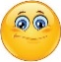  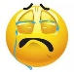 | Date: ___________________________________________________
 | Teacher’s signature:  ___________________________ | Parent’s signature:  ___________________________

- Label and colour.
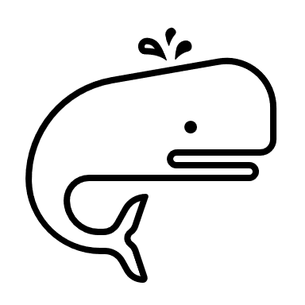 | 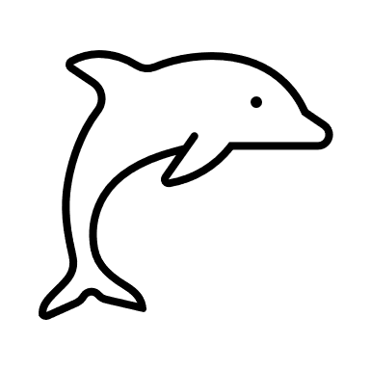 | 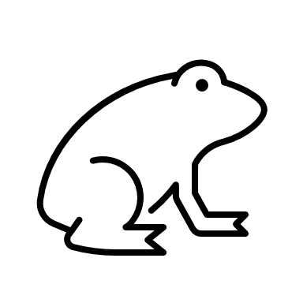 | 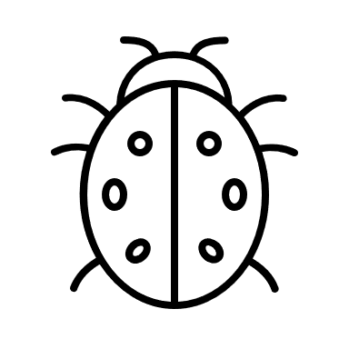 | 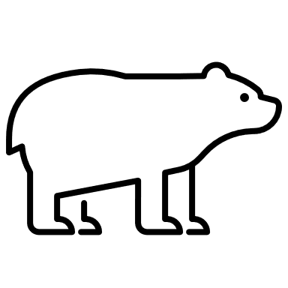
__________ | __________ | __________ | __________

2) Fill in the gaps.
It is blue. It is a _____________________________.
It’s not a river. It’s a _________________________.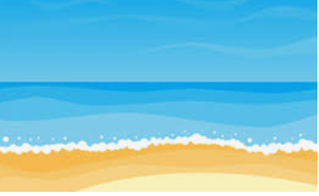
It is green and high. It’s a ____________________. 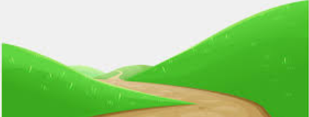
It is in the forest, It’s a _____________________. 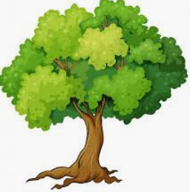

Answer key
- Whale; dolphin; frog; ladybug; bear
- River; sea; hill; tree.

