Name: ____________________________ Surname: ____________________________ N^{ber}: ____ Grade/Class: _____
Assessment: _____________________________ | Date: ___________________________________________________
 | Teacher’s signature:  ___________________________ | Parent’s signature:  ___________________________

- Complete.

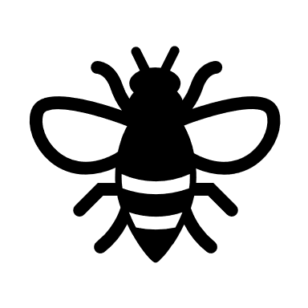

W __ a __ __ d__ __ p __ I __ __ e __ __ r __ __ b __ __ r

- Complete the sentences.
- There is a ___________ in the _________.
- There is a ___________ on the __________.
- There is a ___________ in the 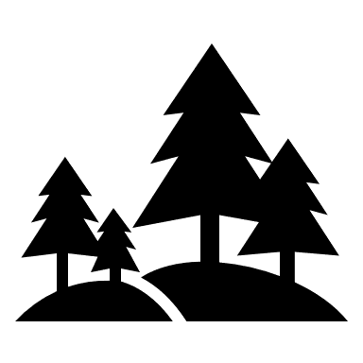___________.
- There is a ___________ in the 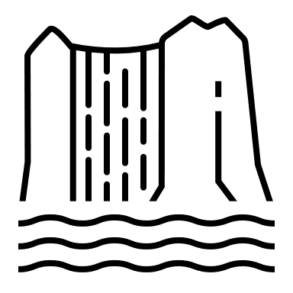____________.

Answer key

- Whale; dolphin bee; frog; bear

- a) whale, ocean;
b) bee, flower;
c) bear, forest;
d) frog, river.

