Name: ____________________________ Surname: ____________________________ N^{ber}: ____ Grade/Class: _____
Assessment: _____________________________ | Date: ___________________________________________________
 | Teacher’s signature:  ___________________________ | Parent’s signature:  ___________________________

- Fill in the missing letters.
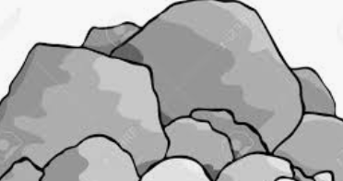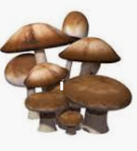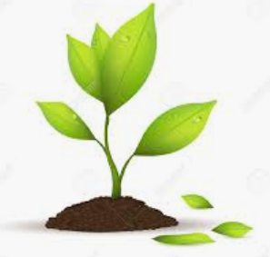
m______________

r_______________

p__________________

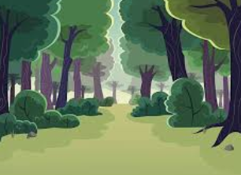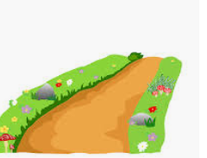

p___________
________t
m________________s

w________________
v_______________

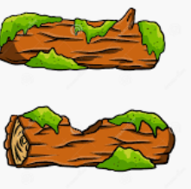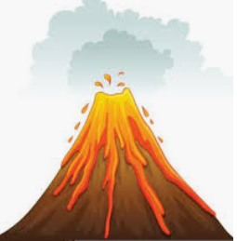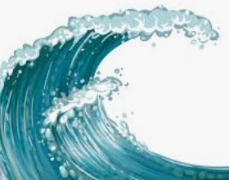

- Write down what you see on the picture.

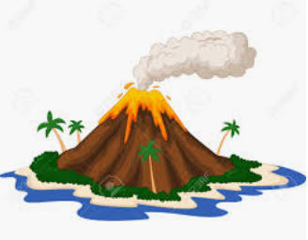
v_______________ p_______________s b _______________ s_______________ o_______________
Answer key
- Rock, mushroom, plant, forest, path, mountains, volcano, wave
- Volcano, plants, beach, smoke, ocean

