Name: ____________________________ Surname: ____________________________ N^{ber}: ____ Grade/Class: _____
Assessment: _____________________________ | Date: ___________________________________________________
 | Teacher’s signature:  ___________________________ | Parent’s signature:  ___________________________

- Complete the words.

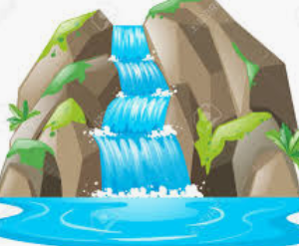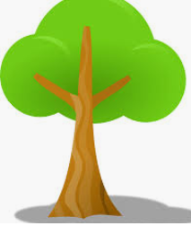
t_________

w_______________

r__________________

m________________

f________________
f_______________s

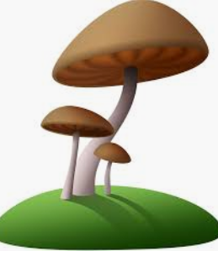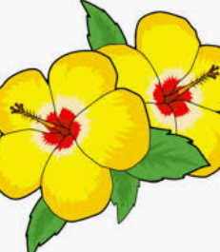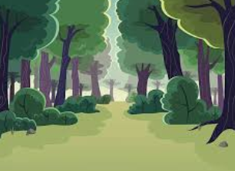

- Circle the things you find in a forest.

- plants d) sunflower g) grass
- flowers e) tree b) mushrooms
- beach f) mountain c) fire

Answer key
- waterfall, tree, river, mushroom, flowers, forest
- plants, flowers, tree, grass, mushrooms.

