Name: ____________________________ Surname: ____________________________ N^{ber}: ____ Grade/Class: _____
Assessment: _____________________________ | Date: ___________________________________________________
 | Teacher’s signature:  ___________________________ | Parent’s signature:  ___________________________

- Look at the picture and write.

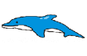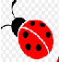 | 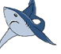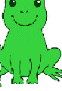

I ________________ and ________________ but I ______________ _________________ and __________.

- Look and write.

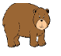

I ________________ and ________________ but I ______________ _________________.

Answer key:
- I like dolphins and ladybirds, but I don’t like sharks and frogs.
- I like bears and whales but I don’t like sharks.

