Name: ____________________________ Surname: ____________________________ N^{ber}: ____ Grade/Class: _____
Assessment: _____________________________ | Date: ___________________________________________________
 | Teacher’s signature:  ___________________________ | Parent’s signature:  ___________________________

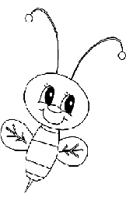
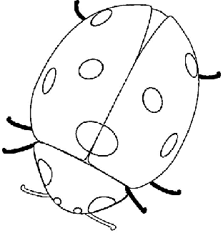
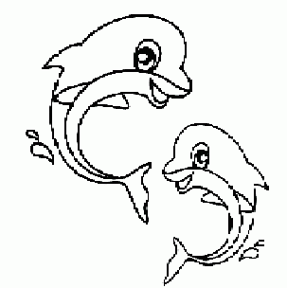
- Colour and write.
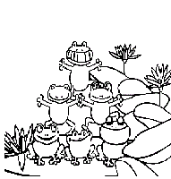
This is a red_______ This is a blue_______
This is a yellow______ That is a green______
2) Look and write.
a) The ____ is ______
b) The ____ is ____
c) The ____ is _____
d) The ____ is _____

Answer key.
- Ladybird; dolphin; bee; frog.
- The frog is green; The ladybird is red; The dolphin is blue; The bee is yellow.

