Name: ____________________________ Surname: ____________________________ N^{ber}: ____ Grade/Class: _____
Assessment: _____________________________ | Date: ___________________________________________________
 | Teacher’s signature:  ___________________________ | Parent’s signature:  ___________________________

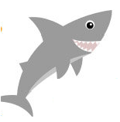
- Write.
This is a shark. It is grey.
This is a _____. It is _____.

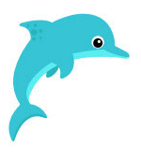
This is a _____. It is _____.
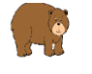
This is a _____. It is ____.
This is a ______ . It is _____.

Answer key.
This is a whale. It is blue.
This is a ladybird. It is red.
This is a dolphin. It is blue.
This is a bear. It is brown.

