Name: ____________________________ Surname: ____________________________ N^{ber}: ____ Grade/Class: _____
Assessment: _____________________________ | Date: ___________________________________________________
 | Teacher’s signature:  ___________________________ | Parent’s signature:  ___________________________

- Look, match and write.
forest | mountain | sea
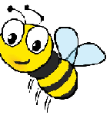
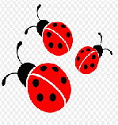
In the sea.
In the mountain.
In the forest.
ladybirds.
There is a bee
There are three
There is a shark
There is bear

- ___________________ b) ________________________
c) ____________________ d) ________________________

- Arrange the words.
shark / The / isn’t / red _____________________
The / isn’t / dolphin / green ____________________
Isn’t / The/ bear/ yellow _____________________
The / blue / ladybird / isn’t _____________________

Answer key:
- There is a bee in the forest.
There are three ladybirds.
There is a shark in the sea.
There is a bear in the mountain.
- The shark isn’t red. The dolphin isn’t green. The bear isn’t yellow. The ladybird isn’t blue.

