TOPIC: Nature | SUBTOPICS: Naming Nature | LEVEL: A1
Name: ____________________________ Surname: ____________________________ N^{ber}: ____ Grade/Class: _____

TOPIC: Nature | SUBTOPICS: Solve the Puzzle | LEVEL: A1
Name: ____________________________ Surname: ____________________________ N^{ber}: ____ Grade/Class: _____
Solve the puzzle using the word clues below. 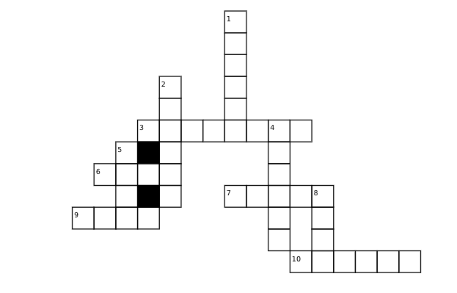
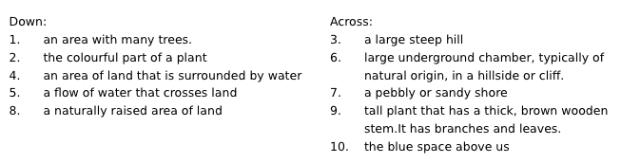

TOPIC: Nature | SUBTOPICS: Match the Nature | LEVEL: A1
Name: ____________________________ Surname: ____________________________ N^{ber}: ____ Grade/Class: _____
ANSWER KEY
Solve the puzzle using the word clues below. 