TOPIC: Nature | SUBTOPICS: Naming Nature | LEVEL: A1
Name: ____________________________ Surname: ____________________________ N^{ber}: ____ Grade/Class: _____

TOPIC: Nature | SUBTOPICS: Circle the Nature | LEVEL: A1
Name: ____________________________ Surname: ____________________________ N^{ber}: ____ Grade/Class: _____

CIRCLE THE NATURE
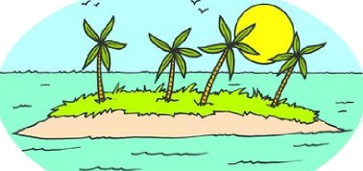
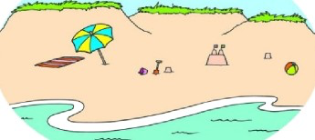
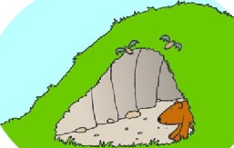
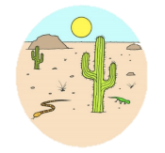
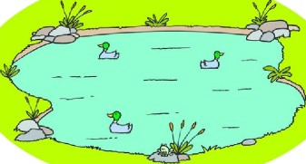
lake pond lake
desert mountain forest
desert cave beach
cave island mountain
beach forest lake

ANSWER KEY
CIRCLE THE NATURE
lake pond lake
desert mountain forest
desert cave beach
cave island mountain
beach forest lake

