TOPIC: Nature | SUBTOPICS: Naming Nature | LEVEL: A1
Name: ____________________________ Surname: ____________________________ N^{ber}: ____ Grade/Class: _____

PICTURE MATCHING
Write the correct word in the box below the picture.
TOPIC: Nature | SUBTOPICS: Match the Nature | LEVEL: A1
Name: ____________________________ Surname: ____________________________ N^{ber}: ____ Grade/Class: _____

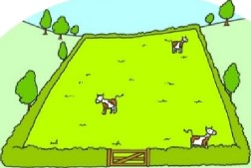 | 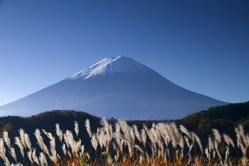 | 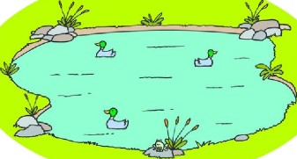 | 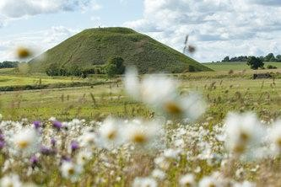
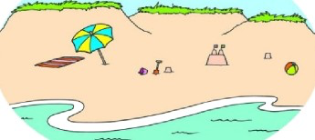 | 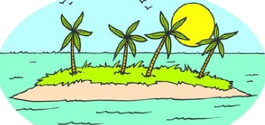 | 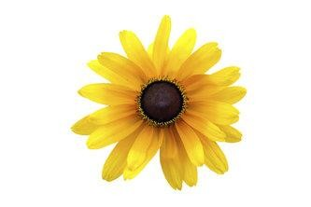 | 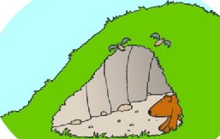
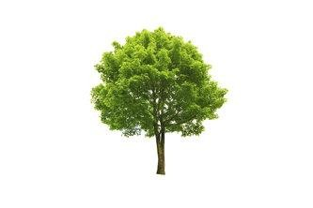 | 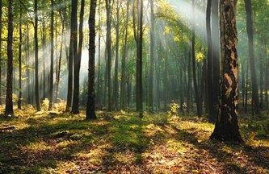 | 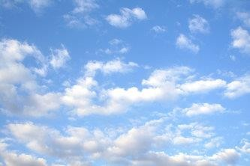 | 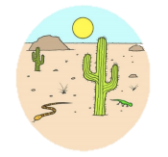

TOPIC: Nature | SUBTOPICS: Complete the Nature’s Words | LEVEL: A1
Name: ____________________________ Surname: ____________________________ N^{ber}: ____ Grade/Class: _____

ANSWER KEY
PICTURE MATCHING
Write the correct word in the box below the picture.
TOPIC: Nature | SUBTOPICS: Match the Nature | LEVEL: A1
Name: ____________________________ Surname: ____________________________ N^{ber}: ____ Grade/Class: _____

Field | mountain | pond | hill
 | island |  | cave
beach |  | flower
tree | forest | clouds | desert

