Name: ____________________________ Surname: ____________________________ N^{ber}: ____ Grade/Class: _____
Assessment: _____________________________ | Date: ___________________________________________________
 | Teacher’s signature:  ___________________________ | Parent’s signature:  ___________________________

- Look, read and correct.
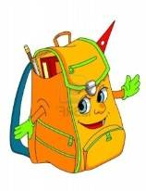
There are eight bags.

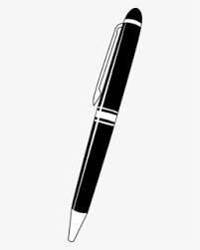
There are seven pens.

There are four flowers.

There are three houses.

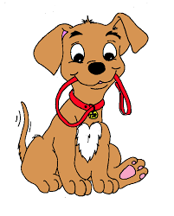
There are six dogs.
There are seven cats.
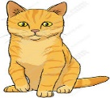
There are ten pencils.

Answer key
There are four bags.
There are ten pens.
There are six flowers.
There are four houses.
There are five dogs.
There are six cats.
There are nine pencils.

