Name: ____________________________ Surname: ____________________________ N^{ber}: ____ Grade/Class: _____
Assessment: _____________________________ | Date: ___________________________________________________
 | Teacher’s signature:  ___________________________ | Parent’s signature:  ___________________________
- Read and fill in the table.
I like pink and purple, but I dont like blue, yellow, green, red and brown.
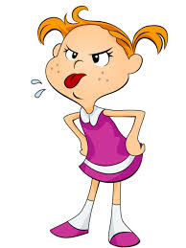
Irma | Irma
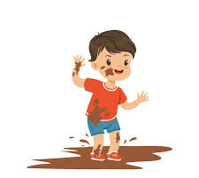
I like red, blue and brown, but I dont like pink, purple and black.
Jason | Jason

Answer key
Irma | Irma
Pink | Red
Purple | Green
 | Blue
 | Yellow
 | Brown

Jason | Jason
Red | Pink
Blue | Purple
Brown

