Name: ____________________________ Surname: ____________________________ N^{ber}: ____ Grade/Class: _____
Assessment: _____________________________ | Date: ___________________________________________________
 | Teacher’s signature:  ___________________________ | Parent’s signature:  ___________________________

- Look and write the colors.

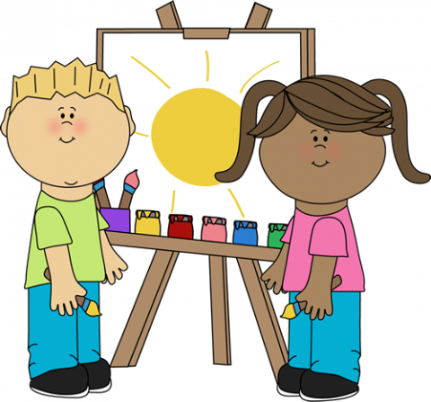

- _______________ sun
- _______________ shoes
- _______________ trousers
- _______________ t-shirt (Girl)
- _______________ t-shirt (Boy)
- _______________ hair (Girl)
- _______________ hair (Boy)

- Look and write the numbers.

There are ___________ children.
There are ___________ brushes.
There is ___________ sun.
There are ___________ paints.

Answer key
Yellow sun
Black shoes
Blue trousers
Pink t-shirt (Girl)
Green t-shirt (Boy)
Brown hair (Girl)
Yellow / BLonde hair (Boy)

- Look and write.

There are two children.
There are four brushes.
There is one sun.
There are five paints.

