Name: ____________________________ Surname: ____________________________ N^{ber}: ____ Grade/Class: _____
Assessment: _____________________________ | Date: ___________________________________________________
 | Teacher’s signature:  ___________________________ | Parent’s signature:  ___________________________

- Look and write.
- Coffee is _____________
- Milk is _____________ 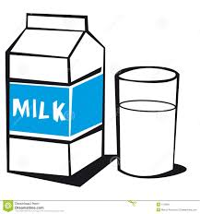
- Apple is _____________ 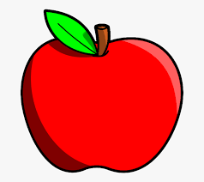
- Lemon is _____________ 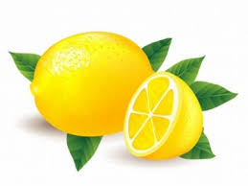
- Watermelon is _____________ and _____________ 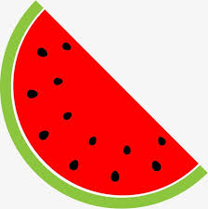
- Orange is _____________ 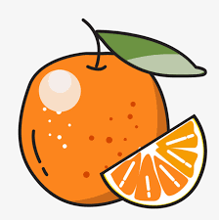
- Complete the words.
P_r_l_
B_a_k
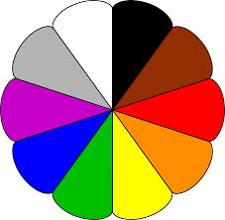
Gr_e_
B_o_n
B__e
R__
P_n_
Y_ll_w
Answer key
- Coffee is brown
- Milk is white
- Apple is red
- Lemon is yellow
- Watermelon is red and green
- Orange is orange
- Purple
Pink
Blue
Green
Red
Black
Brown
Yellow

