Name: ____________________________ Surname: ____________________________ N^{ber}: ____ Grade/Class: _____
Assessment: _____________________________ | Date: ___________________________________________________
 | Teacher’s signature:  ___________________________ | Parent’s signature:  ___________________________
- Answer the questions.
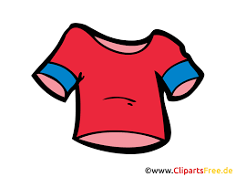
How many __________ are there?
There are _____________________.
28
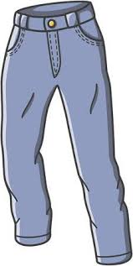
How many __________ are there?
_____________________________________

22
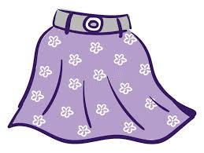
How many __________ are there?
_____________________________________

18
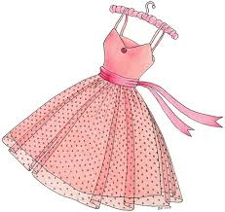
How many __________ are there?
_____________________________________

24

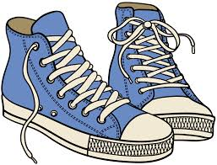
How many __________ are there?
_____________________________________

30

Answer key
- How many t-shirts are there?
There are twenty eight t-shirts.
- How many trousers/jeans are there?
There are twenty two trousers/jeans.
- How many skirts are there?
There are eighteen skirts.
- How many dresses are there?
There are twenty four dresses.
- How many shoes are there?
There are thirty shoes.

