Name: ____________________________ Surname: ____________________________ N^{ber}: ____ Grade/Class: _____
Assessment: _____________________________ | Date: ___________________________________________________
 | Teacher’s signature:  ___________________________ | Parent’s signature:  ___________________________
Look and answer the questions.
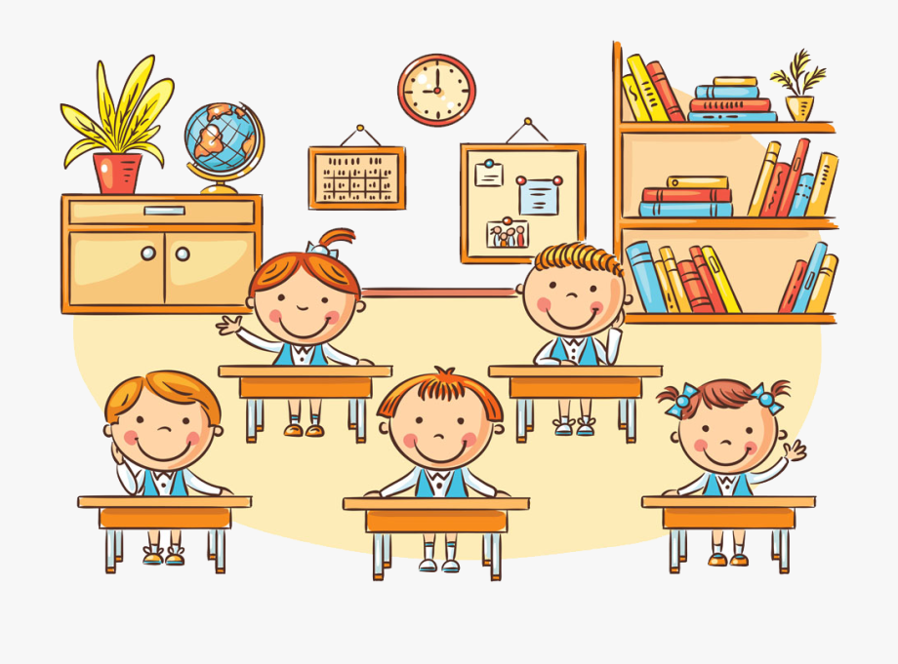
- How many students are there? __________________________
- How many girls are there? __________________________
- How many boys are there? __________________________
- How many books are there? __________________________
- How many clocks are there? __________________________
- How many plants are there? __________________________
Answer key

- How many students are there? There are five students.
- How many girls are there? There are two girls.
- How many boys are there? There are three boys.
- How many books are there? There are twenty five books.
- How many clocks are there? There is one clock.
- How many plants are there? There are two plants.

