Name: ____________________________ Surname: ____________________________ N^{ber}: ____ Grade/Class: _____
Assessment: _____________________________  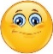  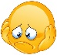  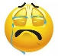 | Date: ___________________________________________________
 | Teacher’s signature:  ___________________________ | Parent’s signature:  ___________________________

- Look and write.
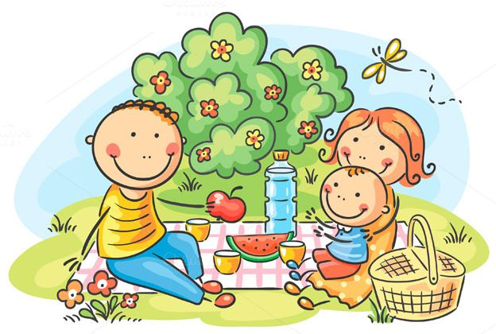
What color is the watermelon? ______________________________
What color is the bottle? ______________________________
What color are the flowers? ______________________________
What color are the glasses? ______________________________
What color is the butterfly? ______________________________
What color is the apple? ______________________________
What color is the sky? ______________________________

Answer key
What color is the watermelon? It’s green and red.
What color is the bottle? It’s blue.
What color are the flowers? They’re orange, yellow and red.
What color are the glasses? They’re yellow.
What color is the butterfly? It’s yellow and white.
What color is the apple? It’s red.
What color is the sky? It’s blue.

