Name: ____________________________ Surname: ____________________________ N^{ber}: ____ Grade/Class: _____
Assessment: _____________________________ | Date: ___________________________________________________
 | Teacher’s signature:  ___________________________ | Parent’s signature:  ___________________________

- Look and write the colors of the fruits. (Example: “BLACK OLIVES”)
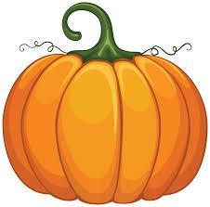
_________________ pumpkin

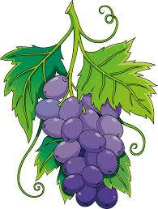
_________________ grapes

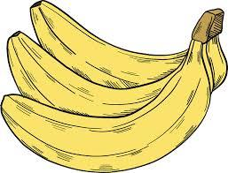
__________ bananas

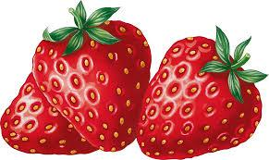
__________ strawberries
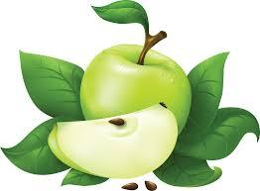
__________ apple
Answer key
- orange pumpkin
- Purple grapes
- Yellow bananas
- Red / pink strawberries
- Green apple

