Name: ____________________________ Surname: ____________________________ N^{ber}: ____ Grade/Class: _____
Assessment: _____________________________ | Date: ___________________________________________________
 | Teacher’s signature:  ___________________________ | Parent’s signature:  ___________________________

- Listen and write the correct number in the box.

 | 7 | 17 | 70
 | 8 | 18 | 80
 | 9 | 19 | 90
 | 5 | 15 | 50
 | 1 | 11 | 100
 | 2 | 12 | 20
 | 3 | 13 | 30
 | 4 | 14 | 40
 | 6 | 16 | 60

- How many books are there? 4. How many cars are there?
______________________________ ___________________________

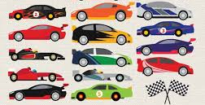

- What color are the books? 5. What color is the car?
________________________________ _____________________________

Script
seventeen
eighty
nineteen
fifty
one
twelve
thirty
four
sixty

- There are 17 books
- They are blue, red and white
- There are fourteen cars.
- It is green.

