Name: ____________________________ Surname: ____________________________ N^{ber}: ____ Grade/Class: _____
Assessment: _____________________________ | Date: ___________________________________________________
 | Teacher’s signature:  ___________________________ | Parent’s signature:  ___________________________

- Listen, write the colors and paint the objects.

___________________ _____________________ ______________________

___________________ ____________________ ______________________
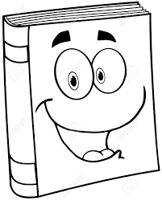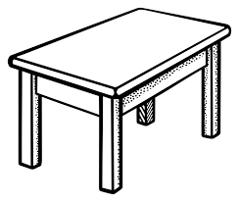

____________________ ____________________ _____________________
Answer key

A green board
A brown book
Orange scissors
A blue glue
A green ruler
A grey sharpener
A pink eraser
A purple pencil
A black desk

