Name: ____________________________ Surname: ____________________________ N^{ber}: ____ Grade/Class: _____
Assessment: _____________________________ | Date: ___________________________________________________
 | Teacher’s signature:  ___________________________ | Parent’s signature:  ___________________________

- Read and paint.
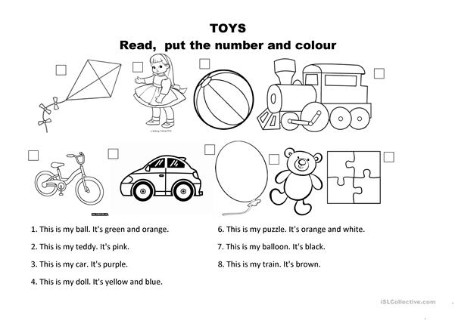
- Look, paint and write.
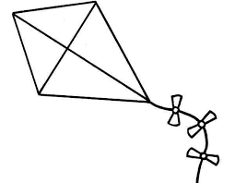
MY KITE
_____________________________________________________

