Name: ____________________________ Surname: ____________________________ N^{ber}: ____ Grade/Class: _____
Assessment: _____________________________ | Date: ___________________________________________________
 | Teacher’s signature:  ___________________________ | Parent’s signature:  ___________________________

- Read and match
40
86
Thirty five

Eighty six
62

Fourty
77
Sixty two
29
Twenty nine

Fifty three
35
53
Seventy seven

- Answer the questions
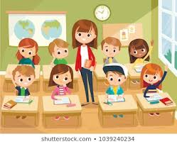
- How many boys are there?
______________________________
- How many girls are there?
______________________________
- What color is the clock?
______________________________
- What color are the desks?
___________________________
Answer key
35
Thirty five

86
Eighty six

40
Fourty
62
Sixty two
29
Twenty nine

Fifty three
53

Seventy seven
77

- There are four boys.
- There are four girls.
- It is white.
- They are brown.

