Name: ____________________________ Surname: ____________________________ N^{ber}: ____ Grade/Class: _____
Assessment: _____________________________  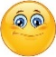  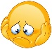  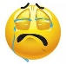 | Date: ___________________________________________________
 | Teacher’s signature:  ___________________________ | Parent’s signature:  ___________________________

- Read and color.
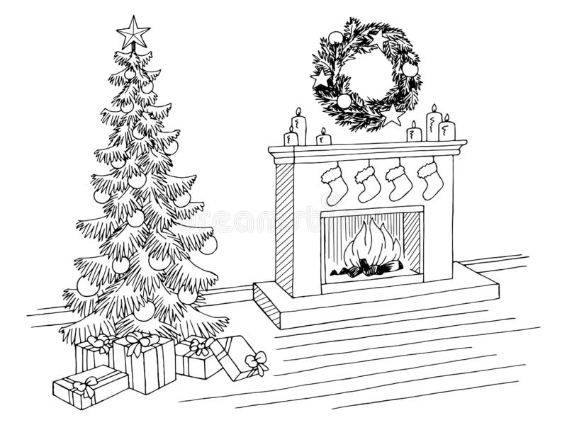

Tree is green.
Balls are yellow.
Boxes are blue, purple, pink, red and yellow.
Fire is red and orange.
Socks are red and white.
Candles are red.
Stars are yellow

